**Student Name*: Yash Gupta***

**UID*: 20BCS5009***

**Date of Performance*: 11/9/20***

**Branch: *CSE*  Section/Group*: Group 1***

**Subject Name*: Electronic***

***AIM***

1. ***Design a two-way switch for room light (XOR).***
2. ***Design an LED Flasher (NAND).***
3. ***Design a multiplayer game trigger mechanism (NOR).***

***Task to be done***

***Requirements***

* 7400 (NAND) IC
* 7402 (NOR) IC
* 7486 (XOR) IC
* 5V Power Supply
* Breadboard
* Connecting wires

***Circuit diagram***

1. 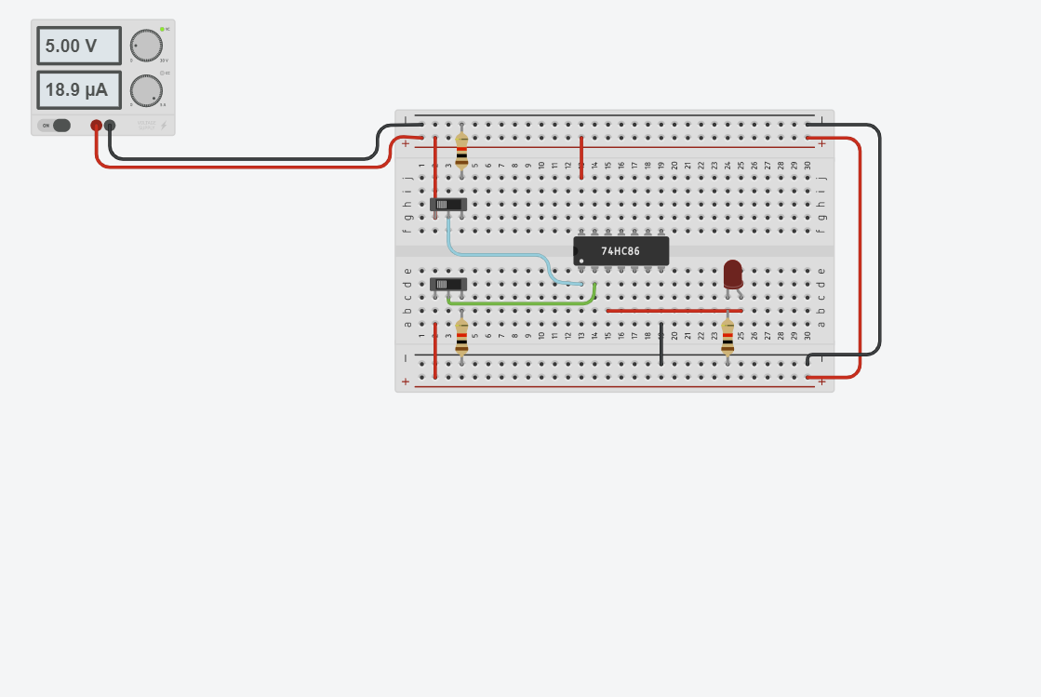
2. 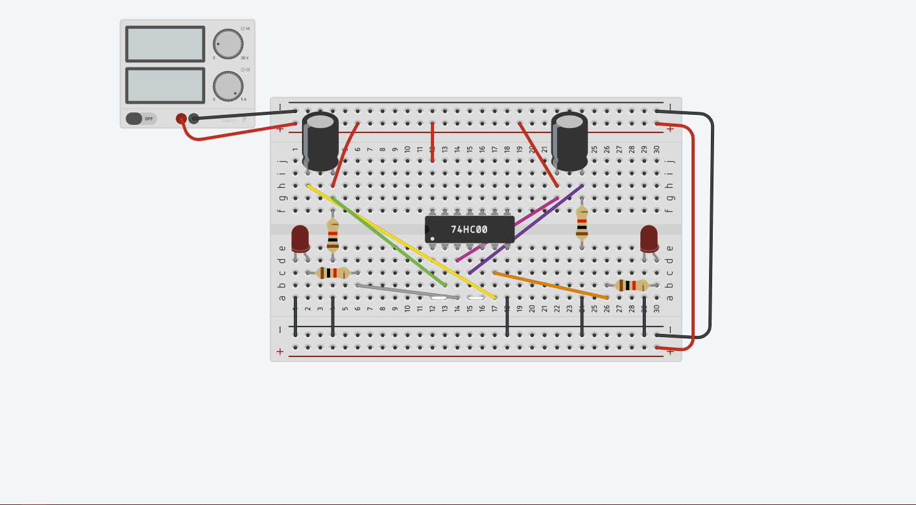
3. 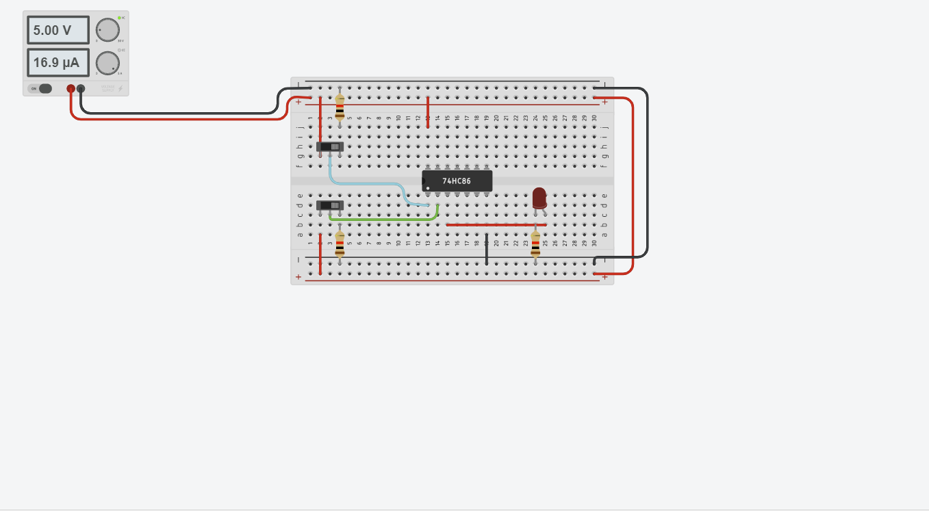

***Simulation Results***

1. 

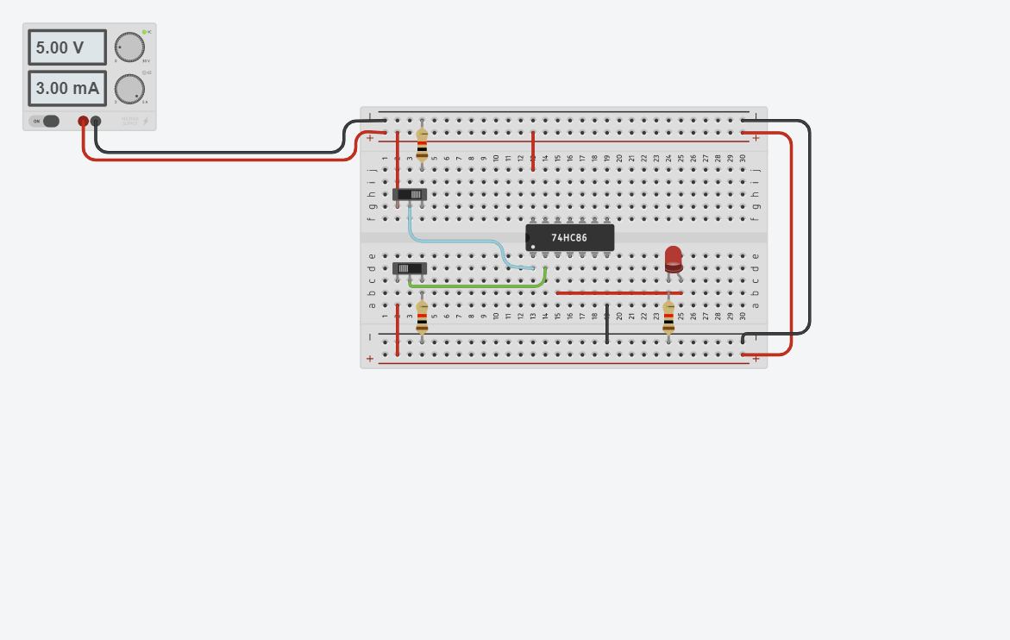

1. 

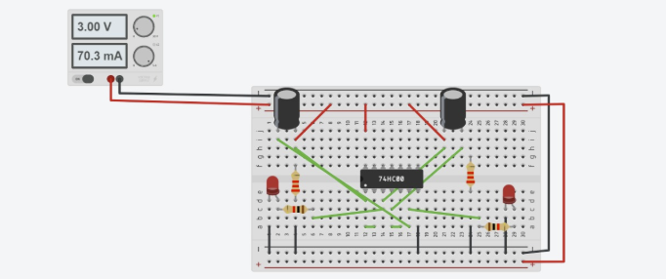

***#laukik helped me in this one***

***Concept used***

* ***In design a two-way switch for room light we used XOR gate***
* ***In design an LED Flasher we used NAND gate***
* ***In design a multiplayer game trigger mechanism we used NOR gate***

**Learning**

* ***The use of different sorts of gates is day to day life rutine***

**Troubleshooting**

* **Circuit break down due to high power flow**